PHYS 202 Force on a current carrying conductor Name:______________________

Force on a current (I) carrying conductor of length, L in a magnetic field, B is given by:
$F=ILB\sin{θ};$ where θ is the angle between the current and magnetic field.

1. [OSCP-Ch22-P40] The force on the rectangular loop of wire in the magnetic field in Figure 22.56 can be used to measure field strength. The field is uniform, and the plane of the loop is perpendicular to the field. (a) What is the direction of the magnetic force on the loop? Justify the claim that the forces on the sides of the loop are equal and opposite, independent of how much of the loop is in the field and do not affect the net force on the loop. (b) When a current of 5.00 A is used, if the force on the 20.0-cm-wide loop is 50 mN, what is the strength of the magnetic field?
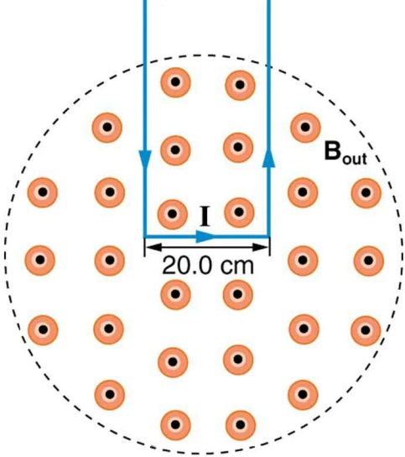

2. [CJ10-Ch21-P40] A horizontal wire is hung from the ceiling of a room by two massless strings. The wire has a length of and a mass of 0.080 kg. A uniform magnetic field of magnitude 0.070 T is directed from the ceiling to the floor. When a current of exists in the wire, the wire swings upward and, at equilibrium, makes an angle with respect to the vertical, as the drawing shows. Find (a) the angle and (b) the tension in each of the two strings.
